Name: Gauri Kishor Naik

Roll-no: 6569

Class: SYCS / A

Subject: Data Science

***GLOBAL TERRORISM***

***DATASET***

SUBMITTED BY-

6569-Gauri Kishor Naik

SYCS / A

 

Mahatma Education Society’s

**Pillai College of Arts, Commerce & Science**

**(Autonomous)**

**Affiliated to University of Mumbai**

NAAC Accredited 'A' grade (3 cycles)

Best College Award by University of

Mumbai

**CERTIFICATE**

***This is to certify that Miss. Gauri Naik of S.Y B.Sc. C.S. Semester IV has completed the practical work in the Subject of DATA SCIENCE (DS) during the academic year 2021-22 under the guidance of Prof. Sanjana Bhangale being the partial requirement for the fulfilment of the curriculum of Degree of Bachelor of Science in Computer Science, University of Mumbai.***

Place: Airoli

Date:

**Name & Signature of faculty:**

**Name & Signature of external:**

INTRODUCTION OF DATASET:

The dataset is of ‘Global Terrorism’. It consists of around 181691 rows and 135 columns. The dataset gives us the information about world-wide happened terrorist activites from 1970s to 2017s. This dataset was taken from kaggle.com. Analysis has been done on this dataset using pandas, numpy, matplotlib and seaborn libraries. Visualization is done by the seaborn libraries using various graphs and plots.

***Importing Libraries:***

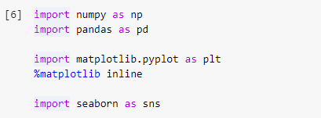

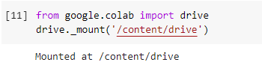

***Reading the .csv file:***



***The dataset:***

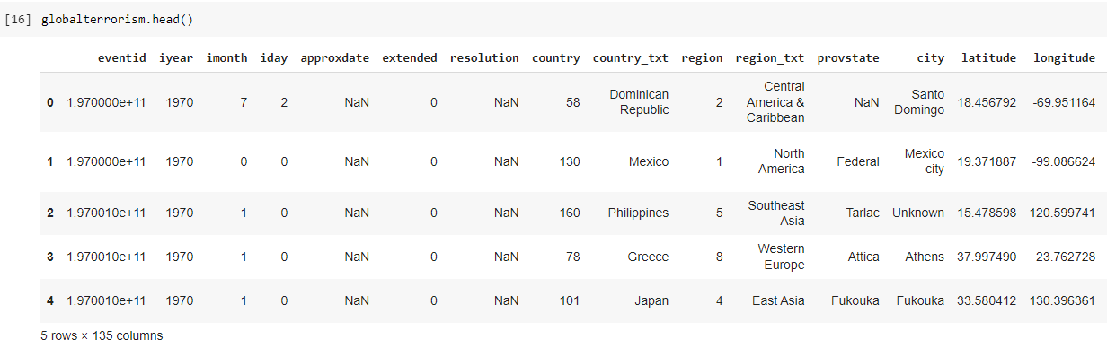

***Columns present in the dataset:***

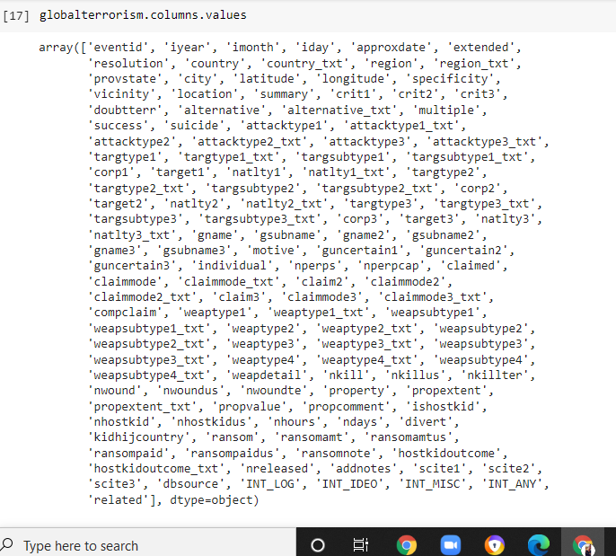

***Total number of columns are rows present:***

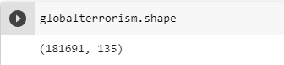

***Renaming columns:***



***Viewing data:***

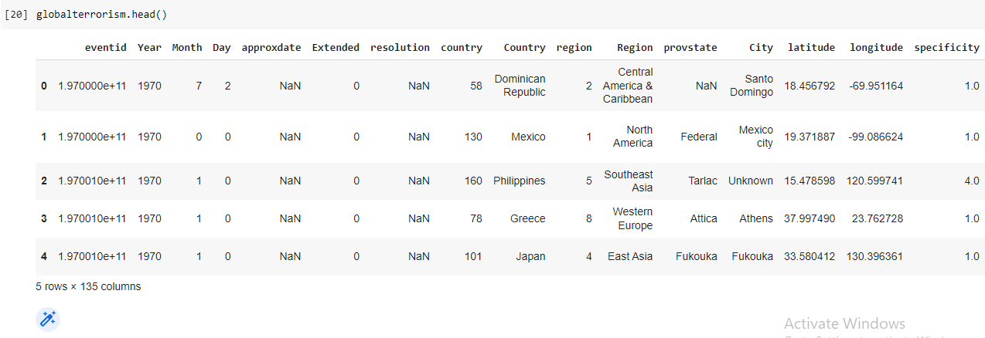

***Columns to be used:***



***Size of the dataset:***

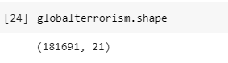

***Column names:***

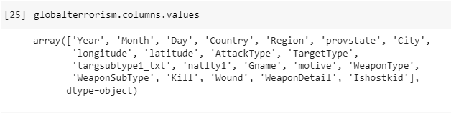

***Visualizing data:***

**1.**

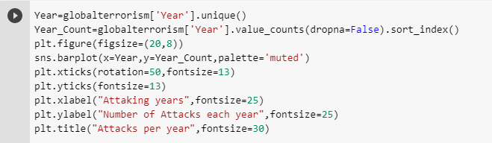

***Output:***

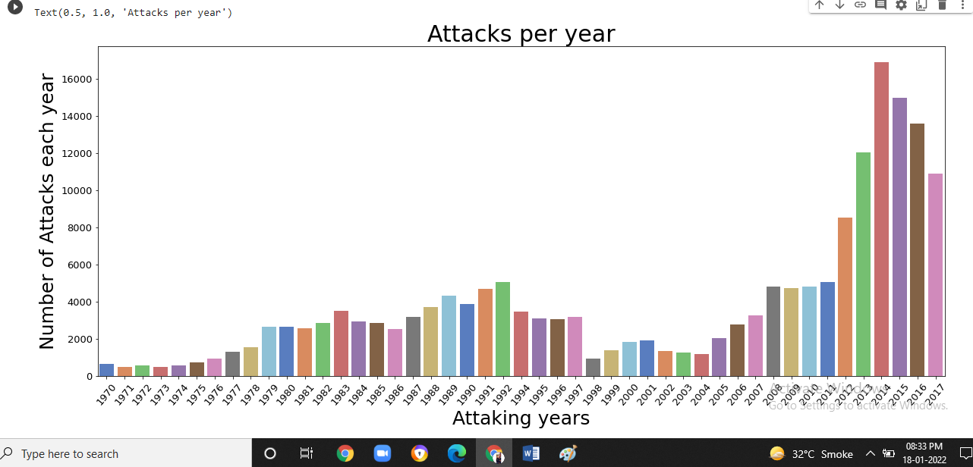

***Insight:***

*The most number of attacks happened in the year 2014.*

**2.**

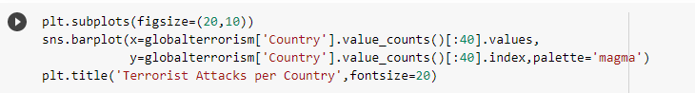

***Output:***

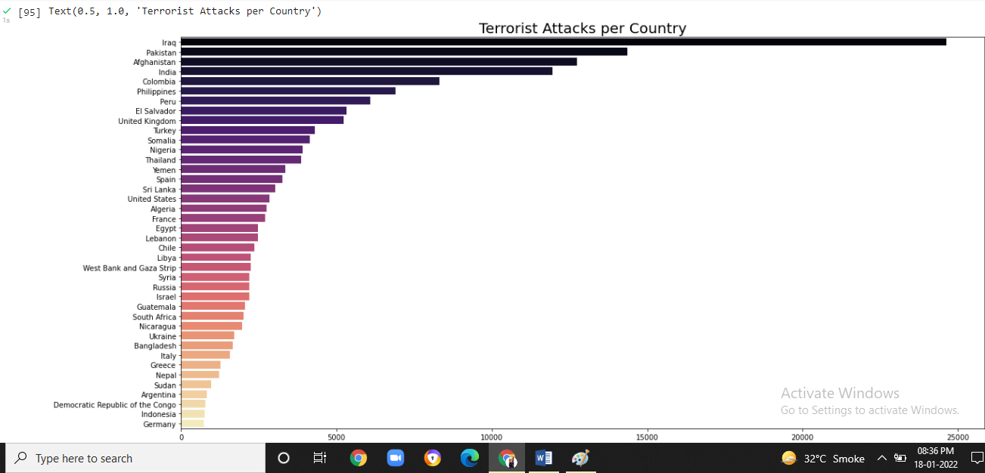

***Insight:***

*Most attacked country by the terrorist is Iraq.*

**3.**

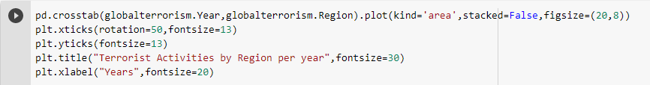

***Output:***

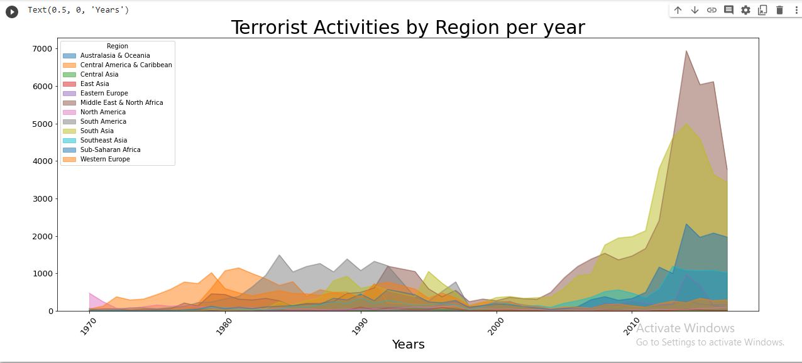

***Insight:***

*Most attacked regions are 1) Middle East and North Africa*

*2) South Asia*

*3) South America*

**4.**

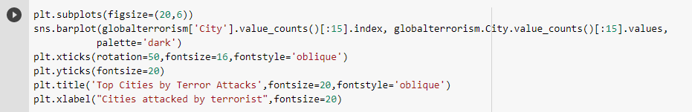

***Output:***

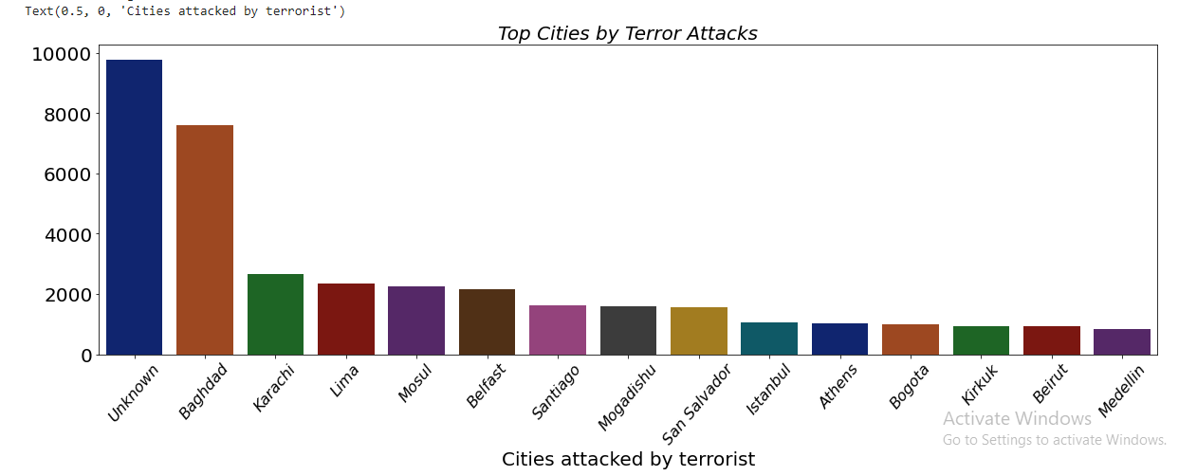

***Insight:***

*The most attacked city is Baghdad.*

**5.**

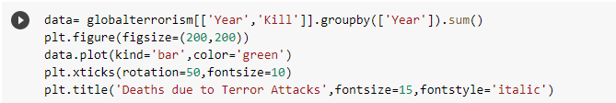

***Output:***

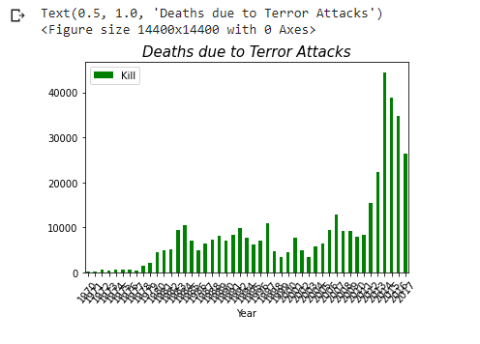

***Insight:***

*Most kills happened in the year 2014.*

**6.**

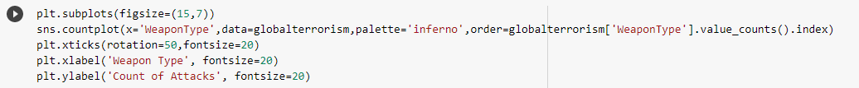

***Output:***

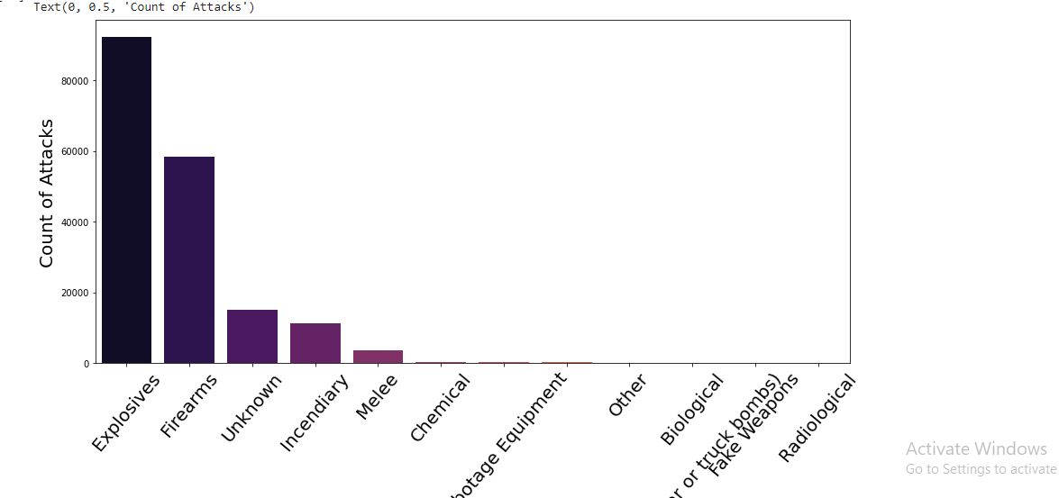

***Insight:***

*Explosive are used the most in the terror attacks and then firearms.*

**7.**

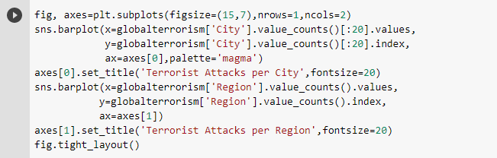

***Output:***

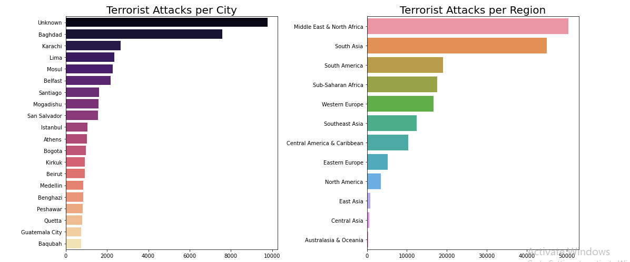

**8.**

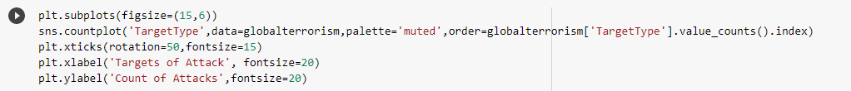

***Output:***

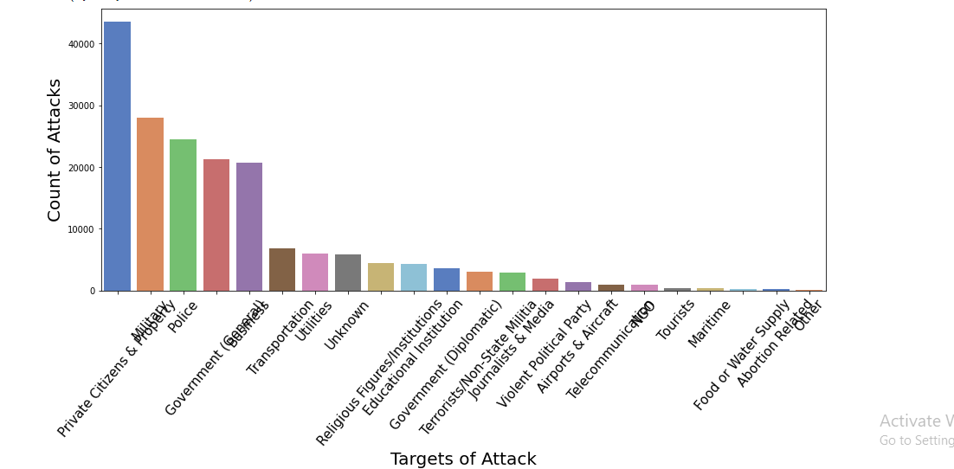

***Insight:***

*Private citizens and property are the most destroyed in the attacks.*

**9.**

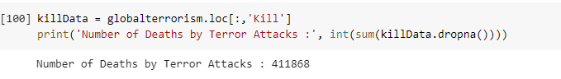

**10.**

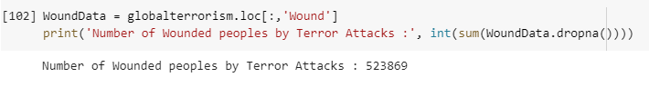

**11.**

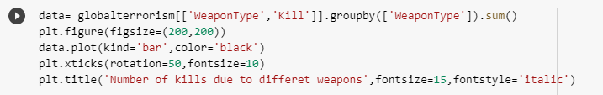

***Output:***

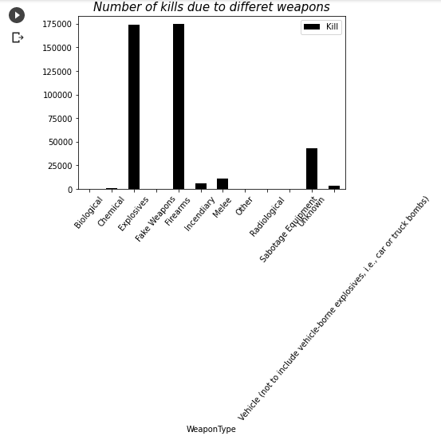

**12.**

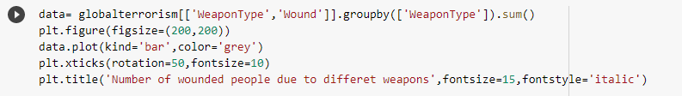

***Output:***

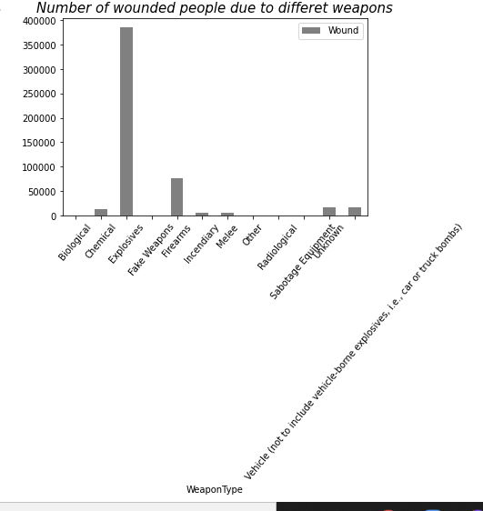

**13.**

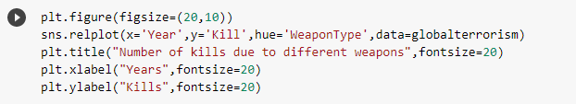

***Output:***

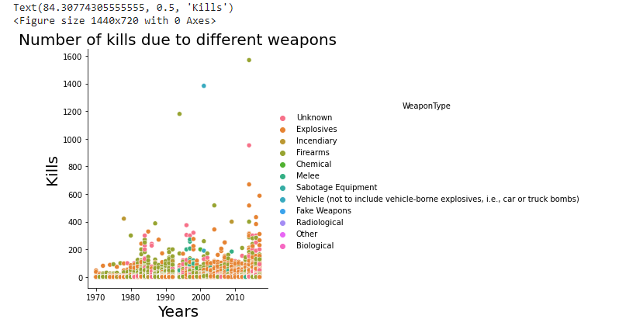

**14.**

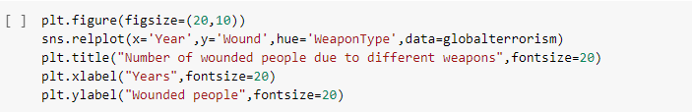

***Output:***

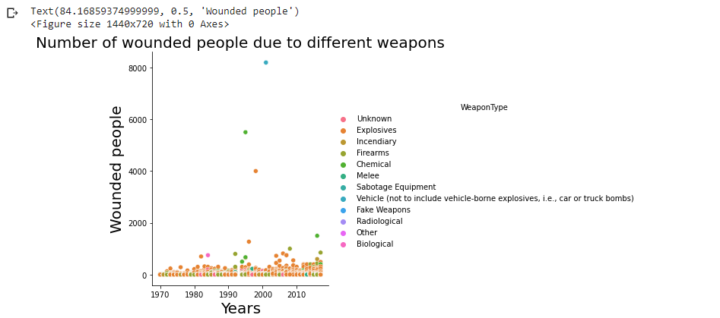

REFERENCE:

